* o An overview of your design and design decisions

The design process involved researching similar games and applications and testing various colour schemes. The final design that was settled upon by the group features a simplistic and stylish design, utilising the use of neutral yet bright colours, which leap from the screen. This design was intended to grab the users attention and entice them to play the game.

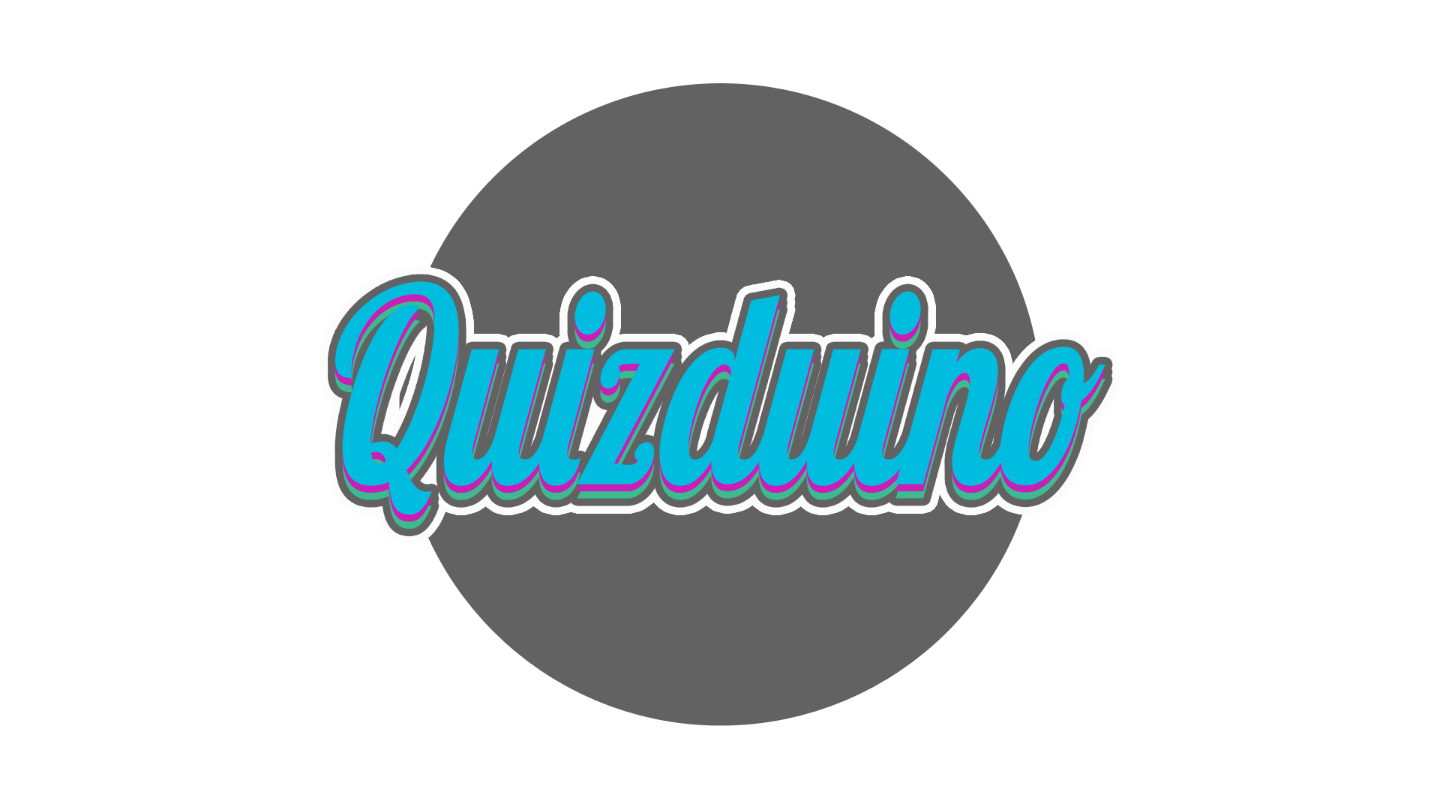

For the logo we went for a simple design with a circular grey background with the word Quizduino in the centre. The text colour is aqua blue with grey and light pink edges to make the outline stand out more.



This is the main background where every interaction will be performed. The colour scheme was specially chosen to be neutral so as not to interfere visually when playing the game.



These symbols are used to represent the leaderboards. The symbols will be assigned to the top 3 players and the rest of the players will be displayed below without a symbol in a list.

The question ‘state’ shall be displayed visually by the use of colour. The images below and their description explain how this is achieved.



When question is initially displayed i.e. not yet answered, the colour shall remain blue.



When the question has been answered correctly, the colour shall change to green.



An incorrect answer to the question shall result in the colour changing to red.

o A critical evaluation of your code

* o Contributions of the group members